NARRATIVE SECTOR GENERATION
STEP 1 & 2: CHOOSE STARTING REGION & DETERMINE THE NUMBER OF SETTLEMENTS (Ironsworn: Starforged – pg. 106)
Terminus: Settlements are relatively common here, and spaceborne routes between communities are usually well-charted. (D6+1 Settlements here)
Outlands: This region represents an area of recent expansion. Settlements here are scattered, and navigational paths are often uncharted and perilous. (D4+1 Settlements here)
Expanse: Only a few bold pioneers have delved these far flung reaches. (D3 Settlements here)

STEP 3: GENERATE SETTLEMENT DETAILS (Ironsworn: Starforged – pg. 160-163)
For each of the Settlements in your starting sector, roll on the following tables:
- Settlement Name
- Location
- Population
- Authority
- Settlement Projects; roll twice
For now, don’t roll on the other settlement tables. You can reveal other aspects of these places when you visit and interact with them.
SETTLEMENT NAME
1 |  | 21 |  | 41 |  | 61 |  | 81
2 |  | 22 |  | 42 |  | 62 |  | 82
3 |  | 23 |  | 43 |  | 63 |  | 83
4 |  | 24 |  | 44 |  | 64 |  | 84
5 |  | 25 |  | 45 |  | 65 |  | 85
6 |  | 26 |  | 46 |  | 66 |  | 86
7 |  | 27 |  | 47 |  | 67 |  | 87
8 |  | 28 |  | 48 |  | 68 |  | 88
9 |  | 29 |  | 49 |  | 69 |  | 89
10 |  | 30 |  | 50 |  | 70 |  | 90
11 |  | 31 |  | 51 |  | 71 |  | 91
12 |  | 32 |  | 52 |  | 72 |  | 92
13 |  | 33 |  | 53 |  | 73 |  | 93
14 |  | 34 |  | 54 |  | 74 |  | 94
15 |  | 35 |  | 55 |  | 75 |  | 95
16 |  | 36 |  | 56 |  | 76 |  | 96
17 |  | 37 |  | 57 |  | 77 |  | 97
18 |  | 38 |  | 58 |  | 78 |  | 98
19 |  | 39 |  | 59 |  | 79 |  | 99
20 |  | 40 |  | 60 |  | 80 |  | 100
You can let the name stand alone, or pair it with one of the following tags: Base, Citadel, Depot, Fortress, Hold, Landing, Outpost, Port, Station, and Terminal

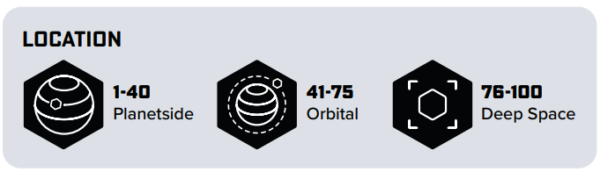
POPULATION
Terminus | Outlands | Expanse | Number
1 – 10 | 1 – 15 | 1 – 20
11 – 25 | 16 – 35 | 21 – 50
26 – 55 | 36 – 65 | 51 – 80
56 – 85 | 66 – 90 | 81 – 95
86 - 100 | 91 - 100 | 96 – 100
AUTHORITY
1 – 15
16 – 30
31 – 45
46 – 55
56 – 70
71 – 85
86 - 100

SETTLEMENT PROJECTS |  |  |  |  | ROLL 2 TIMES
1 – 5 |  | 32 – 33 |  | 63 – 65
6 – 7 |  | 34 – 37 |  | 66 – 69
8 – 9 |  | 38 – 39 |  | 70 – 72
10 – 11 |  | 40 – 41 |  | 73 – 75
12 – 13 |  | 42 – 43 |  | 76 – 78
14 – 17 |  | 44 – 46 |  | 79 – 84
18 – 22 |  | 47 – 49 |  | 85 – 86
23 – 25 |  | 50 – 51 |  | 87 – 88
26 – 27 |  | 52 – 57 |  | 89 – 92
28 – 29 |  | 58 – 59 |  | 93 – 95
30 - 31 |  | 60 – 62 |  | 96 – 100

STEP 4: GENERATE PLANETS (Ironsworn: Starforged – pg. 144)
If any settlements are located on a planet, or in orbit around a planet, you can identify and name the planet to help flesh out the nature of the location.
To learn the planets basic type, roll once on the table below for each planetside or orbital settlement.
Give each planet a name randomly from the Planet Name table or choose one of the sample names for each planet type. For now don’t generate any additional details until you visit those places, and once you do so, roll on the corresponding tables.
PLANETARY CLASS
1 – 15 |  | 71 – 75
16 – 30 |  | 76 – 90
31 – 35 |  | 91 – 92
36 – 50 |  | 93 – 98
51 – 65 |  | 99 – 100
66 – 70

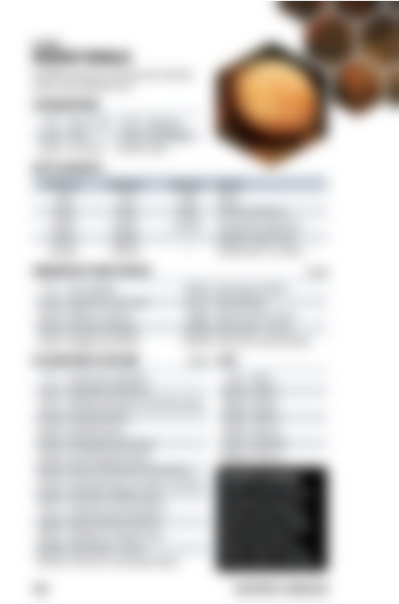
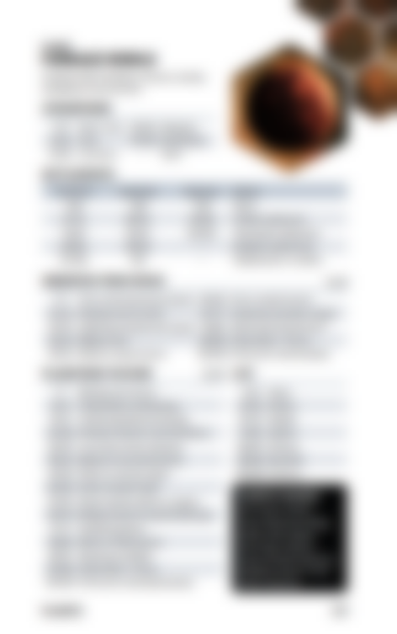
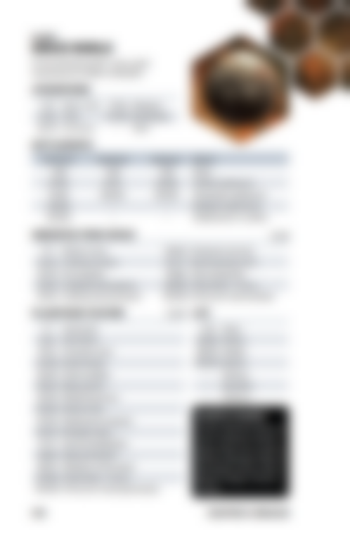
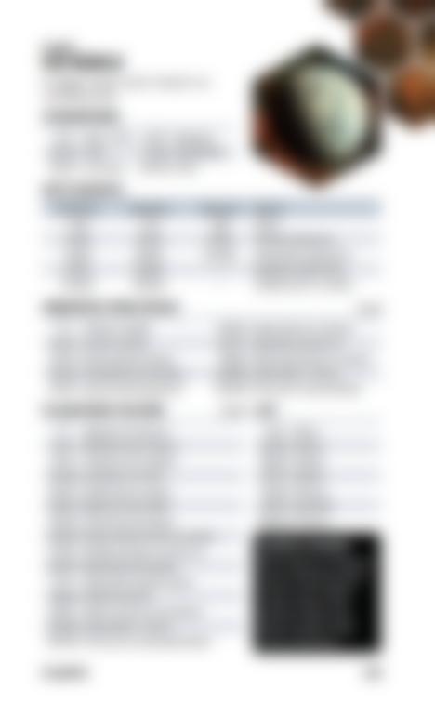
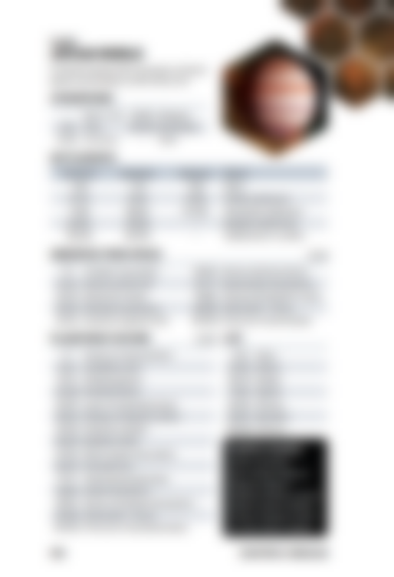
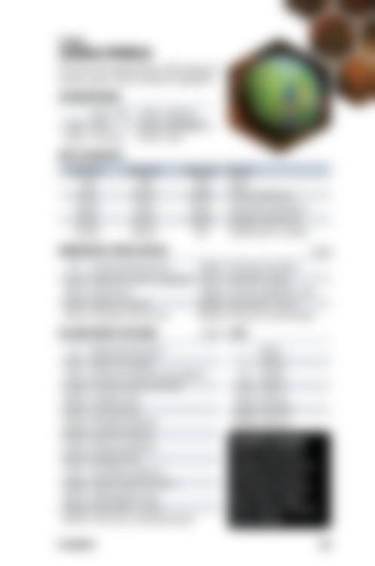
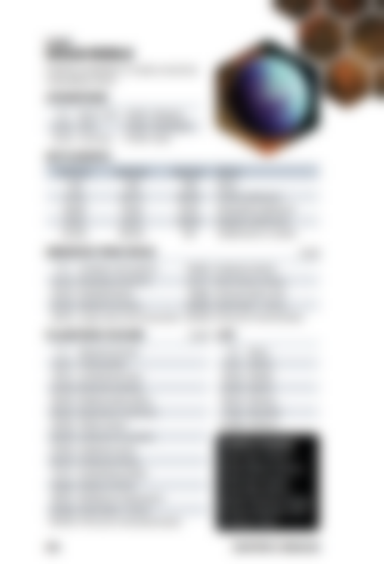
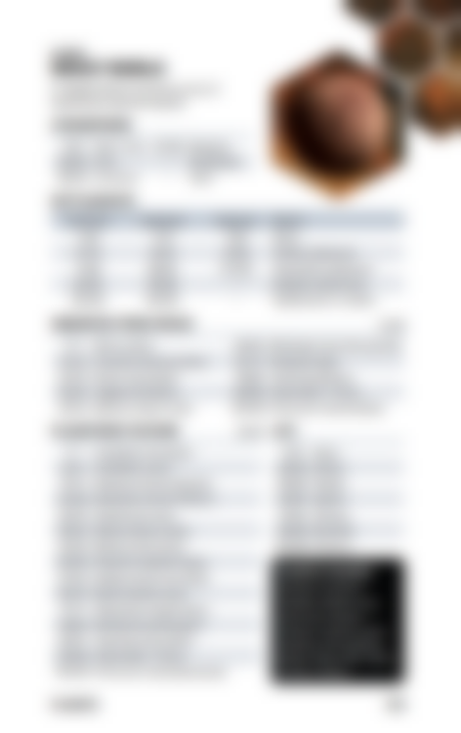
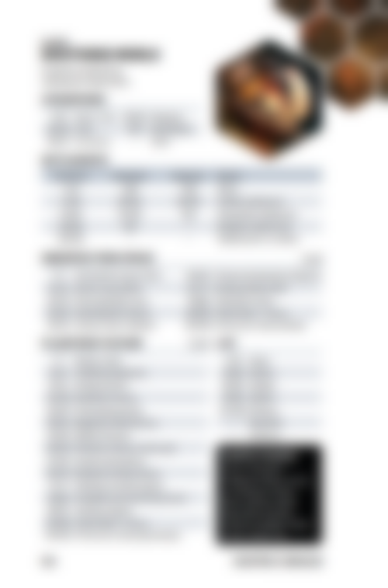
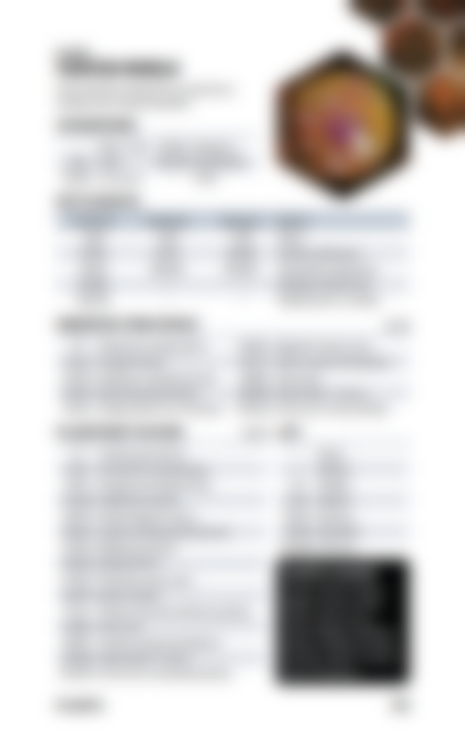
PLANETARY NAME
1 | Abaddon | 21 | Cealdri | 41 | Jol | 61 | Mirage | 81 | Sem-Lor
2 | Abyz | 22 | Coorneeq | 42 | Jord | 62 | Moll Primus | 82 | Sihnon
3 | Alio Prima | 23 | Cormund | 43 | Kamdorn | 63 | Nar | 83 | Starpoint
4 | Aral | 24 | Cresius | 44 | Kostboth | 64 | Neutara | 84 | Tequ’ran
5 | Arc Prime | 25 | Dal Bootha | 45 | Kraag | 65 | New Albion | 85 | Thacoria
6 | Archon Ren | 26 | Della | 46 | Kure | 66 | Paquin | 86 | Thibah
7 | Archon Tau | 27 | Everra | 47 | Lazar | 67 | Parth | 87 | Torkan
8 | Ariel | 28 | Fria | 48 | Lazarus | 68 | Perimeter | 88 | Tren’lak
9 | Arinam | 29 | Gevy | 49 | Lazul Rex | 69 | Phila 53 | 89 | Vaavis
10 | Arnor | 30 | Gninda | 50 | Lemox | 70 | Primor | 90 | Vefut II
11 | Arretza | 31 | Gori | 51 | Lirta IV | 71 | Quall | 91 | Vega
12 | Atlas | 32 | Gral | 52 | Lisis | 72 | Quann | 92 | Velnor
13 | Ba’kal | 33 | Gypso | 53 | Lodor | 73 | Qucen’n | 93 | Vorhal
14 | Bellerophon | 34 | Harus | 54 | Lor | 74 | Quinarra | 94 | Wellon
15 | Belni | 35 | Haven | 55 | Luthen VI | 75 | Rarron | 95 | Whitefall
16 | Bereg | 36 | Hercant | 56 | Mallice | 76 | Resculon | 96 | Wren Terra
17 | Bethi | 37 | Highgate | 57 | Mecatol | 77 | Sakulag | 97 | Xxehan
18 | Beylix | 38 | Hope’s End | 58 | Meer | 78 | Sanctuary | 98 | Zaviri
19 | Bogrineth | 39 | Horizon | 59 | Mehar Xull | 79 | Santo | 99 | Zephyr
20 | Cabbomia | 40 | Jiri | 60 | Mellon | 80 | Saudor | 100 | Zohbat

GENERATE ATMOSPHERE (Every Star an Opportunity)
ATMOSPHERE KEY
None/Thin | Atmosphere is benign but too thin to be breathable. Oxygen supplies must be worn. |  | Marginal |  | The atmosphere is breathable though long term exposure is not recommended.  After 3 missions, off-worlders must roll 1D6 after each mission. On a 1, they fall sick and must miss the following battle.
Toxic | Breathing apparatus must be worn at all times. Buildings are usually sealed and have integrated air supplies.  Any figure that takes a weapons hit during a battle must roll 1D6 after the mission. On a 1 they fall sick and must miss the following battle. |  | Breathable |  | No special equipment or precautions needed.
Corrosive | This planet’s atmosphere is deadly to humans. It can damage exposed skin, materials, plastics, and metals over time.  After every battle, roll 1D4. On a roll of 1, randomly select a character. That character has a random piece of gear break and will need to be repaired. |  | Ideal |  | The atmosphere is beneficial to organic life forms. Each campaign turn a character rests, roll 1D6. On a 1 or 6, they can reduce recovery times by an additional turn.

STEP 5: GENERATE STARS (OPTIONAL) (Ironsworn: Starforged – pg. 141)
If you’d like to know the nature of the primary stars these settlements and planets orbit, roll once on the STELLAR OBJECT table below for each settlement.
STELLAR OBJECT
1 – 15 |  | 76 – 80
16 – 30 |  | 81 – 85
31 – 45 |  | 86 – 90
46 – 50 |  | 91 – 98
51 – 60 |  | 99
61 – 70 |  | 100
71 - 75

STEP 6: INTRODUCE A SECTOR TROUBLE (Ironsworn: Starforged – pg. 116)
You’ve heard rumors of a sector-wide peril, conflict, or mystery. You may roll on the table below to introduce a trouble appropriate to your setting and characters. Note the trouble in your Sector journal.
SECTOR TROUBLE
1 – 5 |  | 51 – 55
6 – 10 |  | 56 – 60
11 – 15 |  | 61 – 65
16 – 20 |  | 66 – 70
21 – 25 |  | 71 – 75
26 – 30 |  | 76 – 80
31 – 35 |  | 81 – 85
36 – 40 |  | 86 – 90
41 – 45 |  | 91 – 95
46 - 50 |  | 96 – 100

STEP 7: NAME THE STARTING SECTOR (Ironsworn: Starforged – pg. 140)
Finally, give your sector a name. If you’re not sure, roll on the SECTOR NAME table below. Write the name in you Sector journal.
SECTOR NAME |  |  |  |  |  |  | ROLL PREFIX & SUFFIX
Roll | Prefix | Suffix |  |  | Roll | Prefix |  | Suffix
1 – 2 |  |  |  |  | 51 – 52
3 – 4 |  |  |  |  | 53 – 54
5 – 6 |  |  |  |  | 55 – 56
7 – 8 |  |  |  |  | 57 – 58
9 – 10 |  |  |  |  | 59 – 60
11 – 12 |  |  |  |  | 61 – 62
13 – 14 |  |  |  |  | 63 – 64
15 – 16 |  |  |  |  | 65 – 66
17 – 18 |  |  |  |  | 67 – 68
19 – 20 |  |  |  |  | 69 – 70
21 – 22 |  |  |  |  | 71 – 72
23 – 24 |  |  |  |  | 73 – 74
25 – 26 |  |  |  |  | 75 – 76
27 – 28 |  |  |  |  | 77 – 78
29 – 30 |  |  |  |  | 79 – 80
31 – 32 |  |  |  |  | 81 – 82
33 – 34 |  |  |  |  | 83 – 84
35 – 36 |  |  |  |  | 85 – 86
37 – 38 |  |  |  |  | 87 – 88
39 – 40 |  |  |  |  | 89 – 90
41 – 42 |  |  |  |  | 91 – 92
43 – 44 |  |  |  |  | 93 – 94
45 – 46 |  |  |  |  | 95 – 96
47 – 48 |  |  |  |  | 97 – 98
49 – 50 |  |  |  |  | 99 – 100

STEP 8: ZOOM IN ON A SETTLEMENT (Ironsworn: Starforged – pgs. 160-164)
It will be helpful to have some additional details for one of the settlements in your starting sector. Choose one of the settlements in your starting sector, whichever is interesting to you. First check for licensing requirements, then roll on the tables on the next pages:
- First Look; roll twice
- Settlement Trouble
- World Traits; roll twice
If the settlement is planetside or in orbit, you can also expand your understanding of that planet. Go to the appropriate planet type, and roll on the corresponding tables:
- Atmosphere
- Observed from Space; roll twice
- Planetside feature; roll twice
- Life
If the planet is a Vital World, also roll on the Diversity and Biomes tables.

FIRST LOOK |  |  | ROLL 2 TIMES
1 – 3 |  | 54 – 56
4 – 9 |  | 57 – 61
10 – 15 |  | 62 – 66
16 – 21 |  | 67 – 72
22 – 26 |  | 73 – 76
27 – 31 |  | 77 – 80
32 – 35 |  | 81 – 83
36 – 40 |  | 84 – 87
41 – 43 |  | 88 – 90
44 – 49 |  | 91 – 100
50 – 53

SETTLEMENT TROUBLE
1 – 3 |  | 50 – 51
4 – 7 |  | 52 – 54
8 – 9 |  | 55 – 57
10 – 13 |  | 58 – 59
14 – 15 |  | 60 – 61
16 – 19 |  | 62 – 64
20 – 23 |  | 65 – 66
24 – 27 |  | 67 – 68
28 – 31 |  | 69 – 70
32 – 33 |  | 71 – 73
34 – 37 |  | 74 – 76
38 – 41 |  | 77 – 78
42 – 44 |  | 79 – 80
45 – 47 |  | 81 – 90
48 -49 |  | 91 – 100

ACTION TABLE
1 |  | 21 |  | 41 |  | 61 |  | 81
2 |  | 22 |  | 42 |  | 62 |  | 82
3 |  | 23 |  | 43 |  | 63 |  | 83
4 |  | 24 |  | 44 |  | 64 |  | 84
5 |  | 25 |  | 45 |  | 65 |  | 85
6 |  | 26 |  | 46 |  | 66 |  | 86
7 |  | 27 |  | 47 |  | 67 |  | 87
8 |  | 28 |  | 48 |  | 68 |  | 88
9 |  | 29 |  | 49 |  | 69 |  | 89
10 |  | 30 |  | 50 |  | 70 |  | 90
11 |  | 31 |  | 51 |  | 71 |  | 91
12 |  | 32 |  | 52 |  | 72 |  | 92
13 |  | 33 |  | 53 |  | 73 |  | 93
14 |  | 34 |  | 54 |  | 74 |  | 94
15 |  | 35 |  | 55 |  | 75 |  | 95
16 |  | 36 |  | 56 |  | 76 |  | 96
17 |  | 37 |  | 57 |  | 77 |  | 97
18 |  | 38 |  | 58 |  | 78 |  | 98
19 |  | 39 |  | 59 |  | 79 |  | 99
20 |  | 40 |  | 60 |  | 80 |  | 100

THEME TABLE
1 |  | 21 |  | 41 |  | 61 |  | 81
2 |  | 22 |  | 42 |  | 62 |  | 82
3 |  | 23 |  | 43 |  | 63 |  | 83
4 |  | 24 |  | 44 |  | 64 |  | 84
5 |  | 25 |  | 45 |  | 65 |  | 85
6 |  | 26 |  | 46 |  | 66 |  | 86
7 |  | 27 |  | 47 |  | 67 |  | 87
8 |  | 28 |  | 48 |  | 68 |  | 88
9 |  | 29 |  | 49 |  | 69 |  | 89
10 |  | 30 |  | 50 |  | 70 |  | 90
11 |  | 31 |  | 51 |  | 71 |  | 91
12 |  | 32 |  | 52 |  | 72 |  | 92
13 |  | 33 |  | 53 |  | 73 |  | 93
14 |  | 34 |  | 54 |  | 74 |  | 94
15 |  | 35 |  | 55 |  | 75 |  | 95
16 |  | 36 |  | 56 |  | 76 |  | 96
17 |  | 37 |  | 57 |  | 77 |  | 97
18 |  | 38 |  | 58 |  | 78 |  | 98
19 |  | 39 |  | 59 |  | 79 |  | 99
20 |  | 40 |  | 60 |  | 80 |  | 100

WORLD TRAITS |  | ROLL 2 TIMES
(5PFH – pgs. 73-75)
Roll | Trait | Description
1 – 3
4 – 6
7 – 8
9 – 10
11 – 12
13 – 14
15 – 16
17 – 18
19 – 20
21 – 22
23 – 24
25 – 26
27 – 29
30 – 32
33 – 34
35 – 36
37 – 38
39 – 41
42 – 43
44 – 46
48 – 48
49 – 51
52 – 53
54 – 55
56 – 57
58 – 59
60 – 62
63 – 64
65 – 67
68 – 69
70 – 72
73 – 74
75 – 76
77 – 79
80 – 81
82 – 84
85 – 86
87 – 89
90 – 91
92 – 93
94 – 96
97 – 100

