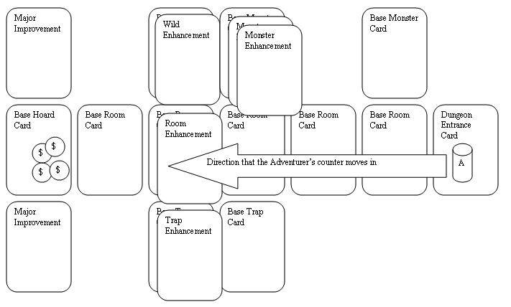
# Gold in Hoard = # players
# Turns = # players
Each Turn = 5 Building Rounds
1 Adventuring Round
Have the most Gold by the end of the game!
Fleeing Adventurer = 1 Gold
Dead Adventurer = 2 Gold

Building Round
- New cards phase
3 from the deck or 3 from the face up or 1 Black card
- Upgrade dungeon phase
1 or more facedown on cards already placed
- Build dungeon phase
No spaces, max of 5 rooms, facedown
- Add dungeon contents phase
Monsters above and traps below
- Improvement or Interference phase
One major improvement card or play a card that has “Interference” written on it.

Raiding the hoard
1 Gold or if none left, 1 stack of cards or 1 major improvement

Adventuring Round
- Movement Phase
Turn room faceup, move counter, door charges = phases stuck
- Room Encounter phase
Turn traps faceup and resolve, then turn monsters faceup and resolve
- Recovery phase
If Morale=0, flee and any other cards may be played

Card List
Yellow Major Adventurer Hinder or Help
Blue or Purple upgrade

Red Major Improvements

Black Major Dungeon Rooms
Double Blue or Purple upgrade

Green Medium Dungeon Rooms
Minor Adventurer Hinder

Grey Minor Dungeon Rooms
Minor Adventure Help

Purple Traps

White Adventurers

Brown Adventuring Party types

Adventurer’s Special Abilities
Bash Cause Str damage to a door or trap (if not disarmed by Thief). Damage removes charges from the door or trap - if the item has no charges left, it is destroyed.
Berserk Autokill: The current monster is killed no matter it's health (does not effect Dragons). The next monster encountered automatically damages the character.
Disable trap Autokill: The revealed trap is destroyed before it goes off (does not effect the DHSSTWKBWPBGS).
Fireball Autokill: The current monster is killed no matter it's health (does not effect Dragons or Lizardmen)
Hatred Autokill: the first monster encountered in the dungeon is killed (does not effect Dragons, choose the next non-Dragon monster instead). If this monster type is encountered again in the dungeon, it may also be killed.
Heal A character that has at least 1 HP goes back to full health.
Illusion A defeated monster becomes a party member. This costs 1 charge for a base monster, 2 for the first upgrade and 3 for a two upgrade monster.
Moral Compass A character that has at least 1 Morale goes back to full morale.
Unlock door Autokill: The door is opened.

