Rollerball
By Peter Cobcroft
This work is licensed under a Creative Commons Attribution-NonCommercial-ShareAlike 2.5 License.

Summary
A single route/multiple route game. Played on a square board with multiple concentric rings. The players have two counters - one for their base, which scores points for whenever the ball runs over it. The other counter is for their workman, whose job it is to run around and make changes to the ring. If the ball runs over the workman, they are returned to base. The ball travels clockwise around the outermost ring and players can build intersections or branches on each ring to divert the ball to other rings.

Bases

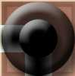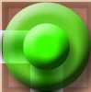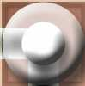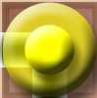

Workmen
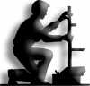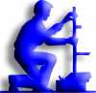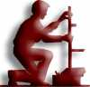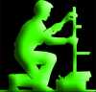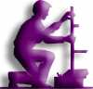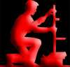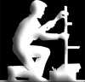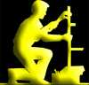

Board
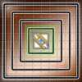
Number of Players: 2-6
Type of Game: Abstract Strategy

Pieces
1 Base and 1 Workman for each player
1 Board
A Deck of 34 Cards-
- 5 of each Track Changer card (25)
- 3 of each Ball Changer card (9)
4 Ball dice
- 1 custom cubic die for each ball showing states of Normal, Energised, Up Rubberised, Down Rubberised, Up Rubberised/Energised, Down Rubberised/Energised

Object of the Game

The winner of this game is the first player that is able to get five victory points.

The players have two counters - one for their base, which scores points whenever the ball runs over it. The other counter is their workman, whose job it is to run around and make changes to the board.

Setup
- Each players takes a base, a worker figure and 5 random cards.
- Each player secretly bids a number of cards from their hand.
Place the cards you wish to bid in your left hand under the table.
- All cards that are bid are discarded to the discard pile.
  - If there is a draw, the players that bid the most may now openly out bid each other by taking turns (starting with the player closest clockwise to the dealer) to add more cards to the discard pile.
  - If the drawing players bid all their cards, the player who bid the least amount is the winner.
    - If there are more than one least bidders, the one closest clockwise to the dealer wins.

Placing initial pieces
- Bases
In clockwise order, starting with the winner of the bid, the players place their bases.
  - Bases may only be placed on corner spaces.
  - Bases never effect the movement of a ball.
  - Bases are never moved and can never be taken off the board.
  - No base may be placed in the inner track.
- Workmen
The players now place their workman anywhere they wish to on the board.
- Cards
Each player that has cards in their hand may place one on any space on the board, or they may pass.
  - Replacer cards may not be used in this stage.
  - A card can only be placed in unoccupied spaces.
  - No part of a card can be placed on a corner space.
  - If a player passes, they may no longer participate in playing cards onto the board.
  - This continues until no player has cards left, or all players have passed.
- Ball
The winner of the bid places the ball on any unoccupied space on the board.

Turns
Each turn, a player (called the Acting Player) performs the following actions :-
- Balls
Move all balls on the board two spaces on their track in a clockwise direction, obeying any diversion cards or other rules to which that ball may be subject.
  - Any ball that would end up in the same space as another ball - and is not in a splitter on the card space marked with a "Y" - pushes the ball forward a space on the track.
  - Any ball that moves over a player's base (in the case of a rubberised ball, it must also be "Down" in that space) earns that player an additional card, even if they have a hand size greater than 4.
    - This card may be immediately placed face up in front of the player as a victory point if they choose to. The cards are placed face up to show all players what cards still remain in the pack.
    - If there are no cards available in the deck, the player may take any card from the board.
  - Any ball that moves over a workman sends that workman back to their base. The player of that workman must also discard a card from their hand if able to.
    - If the workman is on a base counter - their own or another player's, they are not affected by any balls.
    - If the ball is rubberised and "Up" it does not affect the workman.
- New Card
Pick up a new card for their hand if their hand size is less than 4.
  - If the deck is all used up, reshuffle the discards.
  - If there are no cards available in discards either, the acting player receives no card.
- Move workman
Do one of the following two types of move-
  - Move
Move up to three spaces orthogonally on the board.
    - The workman may not enter the middle four squares marked with the Rollerball logo.
    - The workman may occupy any space with a counter, base or other workman.
    - The workman may not enter a space containing a ball unless it is a rubberised ball currently in "Up" mode.
  - Teleport
Discard a card from the acting player's hand and move their workman to any non-ball space on the board.
- Use the workman.
The workman may make no action or may do one of the following three actions-
  - Blow up a diversion card the workman is standing on.
    - Discard a card from the acting player's hand to discard a diversion card that the acting player's workman is standing on. The card on the board must not have any other player's workman on it, and it must not have any ball on it unless it is an "Up" rubberised ball. Move the workman back to the acting player's base.
  - Build on the board
    - Play a diversion card from the acting player's hand underneath the acting player's workman. No space covered by the card may contain a ball, a workman of a different player or any card or base. No part of the card can be on a corner space.
  - Replace a Diversion
    - Play a Replacer card. The diversion card on the board must not have a ball on it at the time (unless that ball is rubberised and in the "Up" position). Discard the replacer card when played and the diversion card the acting player's workman is on, then play another card from the acting player's hand onto the board.
    - The card played must be placed legally - there must be no diversion cards or balls in the spaces and one space of the card must be underneath the acting player's workman.
    - Other players' workman counters may be on the diversion card being replaced or the new card being played.
- 5 and 6 player move.
If there are five or six players in the game, then the player seated 3 position to the acting player's left may also move their workman. The workman may NOT be used, only moved. The player may do one of the following two types of move-
  - Move
Move their workman up to three spaces orthogonally on the board.
    - The workman may not enter the middle four squares marked with the Rollerball logo.
    - The workman may occupy any space with a counter, base or other workman.
    - The workman may not enter a space containing a ball unless it is a rubberised ball currently in "Up" mode.
  - Teleport
Discard a card from their hand and move their workman to any non-ball space on the board.

Diversions
There are two types of diversions - track changers and ball changers.

Track Changers

Track Changers
 |  |  |  | 
Down Move | Replacer | Splitter Down | Splitter Up | Up Move

Track Changers are 1x2 cards played across two tracks of the board. A Track Changer card cannot be played on a corner track square, only on the straight tracks.
No card can be played on top of any other card, base or ball.

Splitting Balls
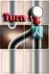  Turn 1 | 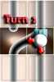  Turn 2 | 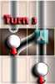  Turn 3 | 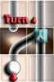  Turn 4

Combining Balls
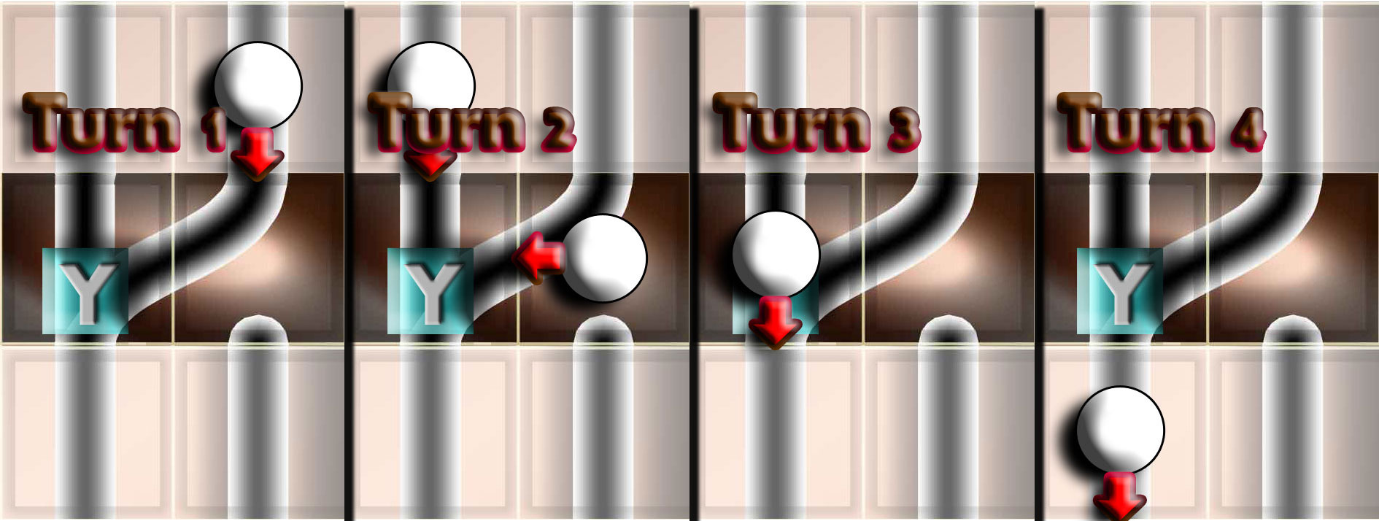
- Up Move
This card moves a ball from a ring to the next ring out.
- Down Move
This card moves a ball from a ring to the next ring in.
- Splitter Up
This card has two roles. It can either split a ball into two balls, or combine two balls into one ball depending on how it is placed.
  - To combine balls, both balls must hit the square containing the "Y" at the same time and if rubberised be in the "Down" position. Otherwise the card is treated as an Up Move card.
  - A ball only splits if there are less than 4 balls currently on the board. If there are 4 balls, the entering ball treats the card as an Up Move.
- Splitter Down
This card has two roles. It can either split a ball into two balls, or combine two balls into one ball depending on how it is placed.
  - To combine balls, both balls must hit the square containing the "Y" at the same time and if rubberised be in the "Down" position. Otherwise the card is treated as a Down Move card.
  - A ball only splits if there are less than 4 balls currently on the board. If there are 4 balls, the entering ball treats the card as a Down Move.
- Replacer
A replacer card changes the diversion your workman is currently on with a card from your hand.
  - The diversion card on the board must not have a ball on it at the time or any other workman. Unless that ball is rubberised and in the "Up" position.
  - Discard the replacer card when played and the diversion card your workman is on, then play another card from your hand onto the board fulfilling all usual legal requirements for card placement.

Dead Ends
If a ball encounters a dead end on a track changer card or at any other time, it is regarded as hopping over the card (in a similar manner to a Up Rubber turn for a rubberised ball) this turn and continues as though the card was not there.

Ball Changers

Ball Changers
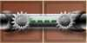 | 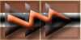 | 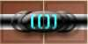
Derubberiser | Energiser | Rubberiser

Balls
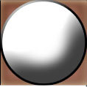 | 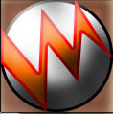 |  |  |  | 
Normal | Energised | Rubber Up | Rubber Down | Energised Rubber Up | Energised Rubber Down

Ball Changers are 2x1 cards played on a single track of the board. A Ball changer card cannot be played on a corner track square, only on the straight tracks.
No card can be played on top of any other card, base or ball. A ball counter is changed from the moment it leaves the Ball Changer card (ie the next square after).
- Energiser
A ball energiser causes it to smash through the next diversion. Remove and discard the next diversion the ball encounters from the board, even if it is another energiser. The ball stops being energised after it hits a diversion and continues on normally (flip the counter from Energised to Ball). An energised ball has no other effect on play.
- Rubberiser
A ball rubberiser causes the ball to bounce over every second square in a track. This may cause it to ignore bases and track changer cards. It won't ignore ball changer cards, however, as they are two spaces long (therefore a Rubberised ball can become Energised, or can become Derubberised).
  - The first square after leaving the Rubberiser, the ball is Up Rubber.
  - Every space the ball is moved, flip the counter between Up Rubber and Down Rubber sides. Note - as balls move two spaces per turn, you should not need to do this other than for reference purposes if ball movements become complicated.
  - While on the Up Rubber side the ball is unaffected by any cards on the board, and does not affect workmen. The ball still follows the track on the board.
- Derubberiser
A ball stabilizer that un-rubberises it.
  - Note: An energised rubberised ball destroys the Derubberiser before it can be used.

Winning the Game
The game is won by the first player to achieve 5 victory points.

