Item | 1  Early Creil Yellow Transferware  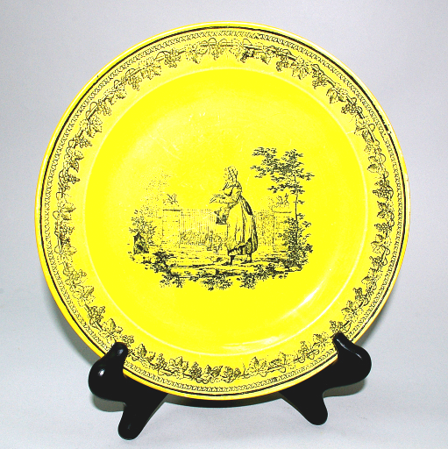 | Item | Item | 1  19th century French Bouillotte Lamp  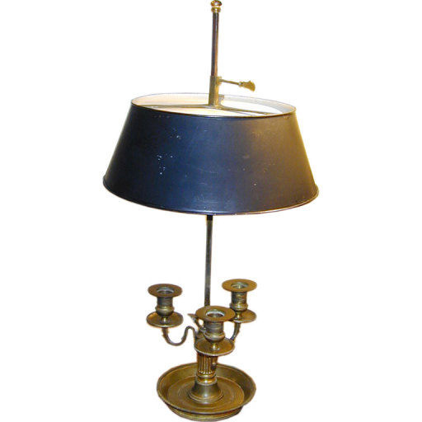 | Item | Item | 1  French Empire Wallpaper Screen  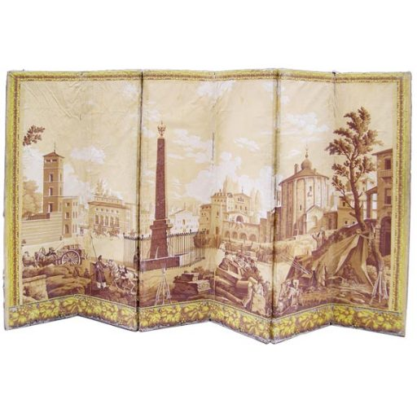 | Item | Item | 2  Stone Table Base  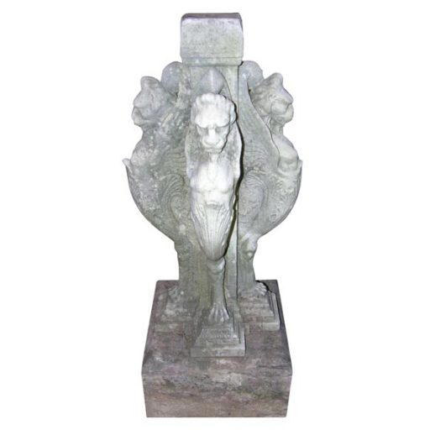 | Item
Item | 2  Pair of Regency Side Cabinets  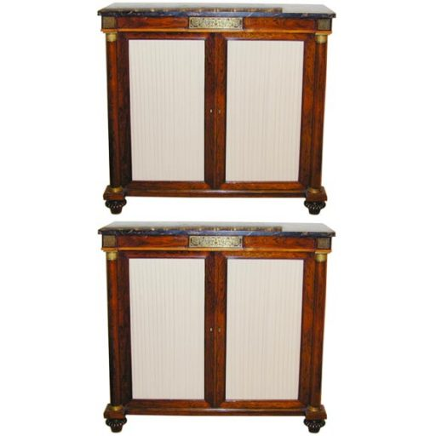 | Item | Item | 2  19th century English marble top table  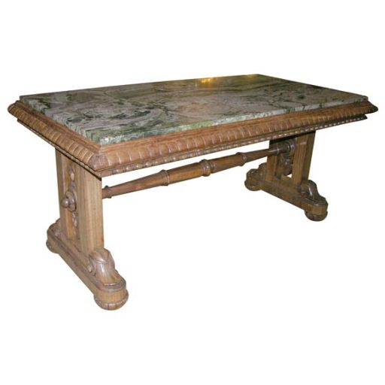 | Item | Item | 3  Gothic revival chairs  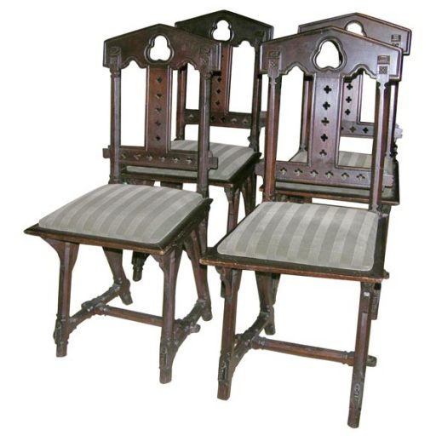 | Item | Item | 3  18th century Japanese Large Jar  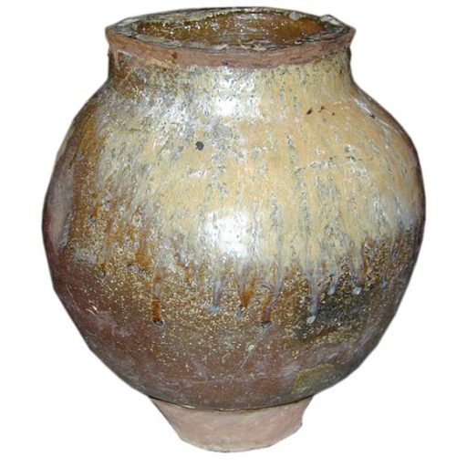 | Item

Item | 3  Antique South Persian Gabbeh  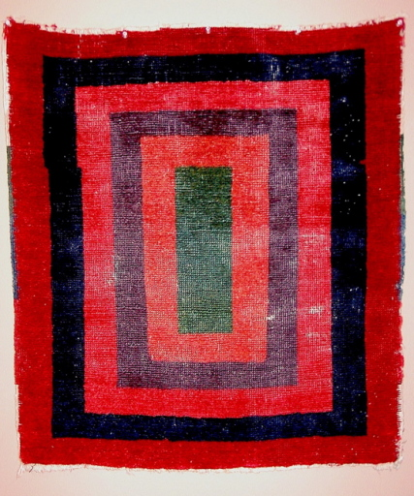 | Item | Item | 5  Large Scale Majolica Centerpiece  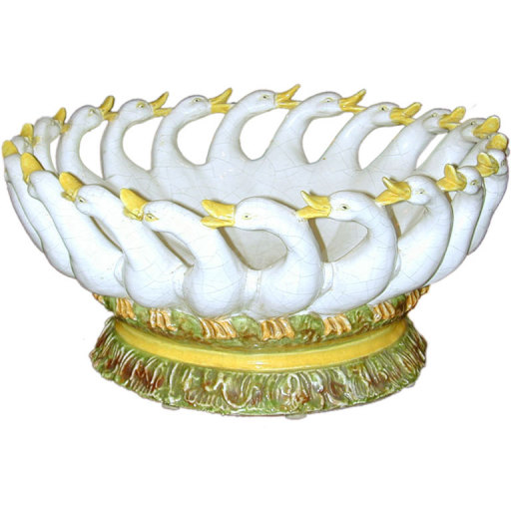 | Item | Item | 5  English Regency Chinoiserie Decorated Papier-Mâché Tray Table  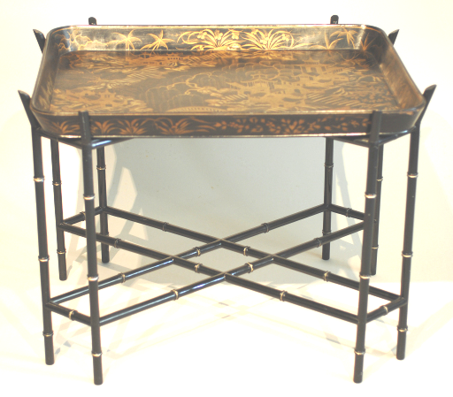 | Item | Item | 5  Solid Mahogany Extending Dining Table C1800  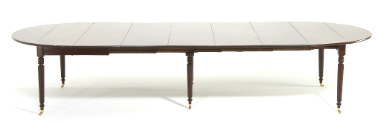 | Item
Item | 8  Chinese Export Armorial Porcelain Punch Bowl  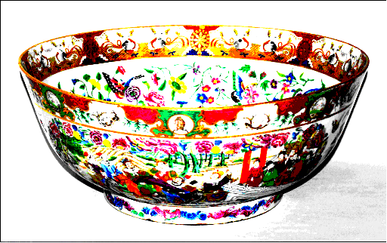 | Item | Item | 8  A George Iii Mahogany Double Sided Writing Table Desk C1800  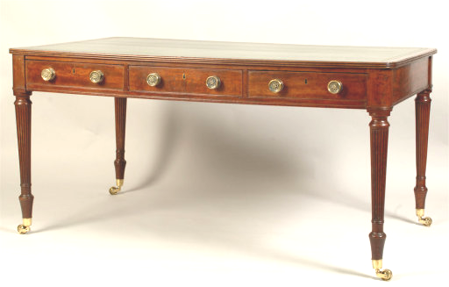 | Item | Item | 8  Pair Of Fine Derby Porcelain Oval Dishes  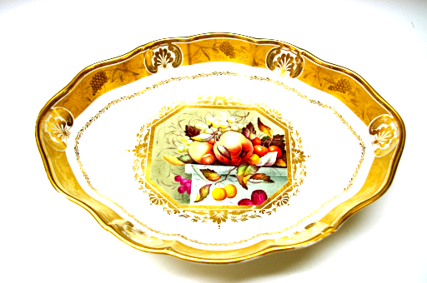 | Item | Item | 13  Peridot Paste Necklace  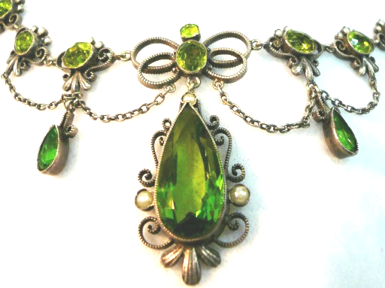 | Item

Item | 13  Pair Louis XVI Style Armchairs  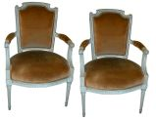 | Item | Item | 21  Pair Louis-XVI-Style Bronze Sconces  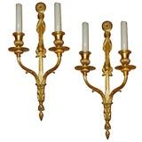 | Item | Priority | 1  Priority 1  Faction 1 | Priority | Priority | 2  Priority 2  Faction 1 | Priority
Priority | 3  Priority 3  Faction 1 | Priority | Priority | 4  Priority 4  Faction 1 | Priority | Priority | 5  Priority 5  Faction 1 | Priority | Priority | 6  Priority 6  Faction 1 | Priority

Priority | 7  Priority 7  Faction 1 | Priority | Priority | 8  Priority 8  Faction 1 | Priority | Priority | 1  Priority 1  Faction 2 | Priority | Priority | 2  Priority 2  Faction 2 | Priority
Priority | 3  Priority 3  Faction 2 | Priority | Priority | 4  Priority 4  Faction 2 | Priority | Priority | 5  Priority 5  Faction 2 | Priority | Priority | 6  Priority 6  Faction 2 | Priority

Priority | 7  Priority 7  Faction 2 | Priority | Priority | 8  Priority 8  Faction 2 | Priority | Priority | 1  Priority 1  Faction 3 | Priority | Priority | 2  Priority 2  Faction 3 | Priority
Priority | 3  Priority 3  Faction 3 | Priority | Priority | 4  Priority 4  Faction 3 | Priority | Priority | 5  Priority 5  Faction 3 | Priority | Priority | 6  Priority 6  Faction 3 | Priority

Priority | 7  Priority 7  Faction 3 | Priority | Priority | 8  Priority 8  Faction 3 | Priority | Priority | 1  Priority 1  Faction 4 | Priority | Priority | 2  Priority 2  Faction 4 | Priority
Priority | 3  Priority 3  Faction 4 | Priority | Priority | 4  Priority 4  Faction 4 | Priority | Priority | 5  Priority 5  Faction 4 | Priority | Priority | 6  Priority 6  Faction 4 | Priority

Priority | 7  Priority 7  Faction 4 | Priority | Priority | 8  Priority 8  Faction 4 | Priority | Priority | 1  Priority 1  Faction 5 | Priority | Priority | 2  Priority 2  Faction 5 | Priority
Priority | 3  Priority 3  Faction 5 | Priority | Priority | 4  Priority 4  Faction 5 | Priority | Priority | 5  Priority 5  Faction 5 | Priority | Priority | 6  Priority 6  Faction 5 | Priority

Priority | 7  Priority 7  Faction 5 | Priority | Priority | 8  Priority 8  Faction 5 | Priority | Priority | 1  Priority 1  Faction 6 | Priority | Priority | 2  Priority 2  Faction 6 | Priority
Priority | 3  Priority 3  Faction 6 | Priority | Priority | 4  Priority 4  Faction 6 | Priority | Priority | 5  Priority 5  Faction 6 | Priority | Priority | 6  Priority 6  Faction 6 | Priority

Priority | 7  Priority 7  Faction 6 | Priority | Priority | 8  Priority 8  Faction 6 | Priority | Priority | 1  Priority 1  Faction 7 | Priority | Priority | 2  Priority 2  Faction 7 | Priority
Priority | 3  Priority 3  Faction 7 | Priority | Priority | 4  Priority 4  Faction 7 | Priority | Priority | 5  Priority 5  Faction 7 | Priority | Priority | 6  Priority 6  Faction 7 | Priority

Priority | 7  Priority 7  Faction 7 | Priority | Priority | 8  Priority 8  Faction 7 | Priority | Representative | Black  Black  Black | Representative | Representative | Red  Red  Red | Representative
Representative | Orange  Orange  Orange | Representative | Representative | Yellow  Yellow  Yellow | Representative | Representative | Green  Green  Green | Representative | Representative | Blue  Blue  Blue | Representative

Representative | Indigo  Indigo  Indigo | Representative

Your Representative | Faction 1  Faction 1 | Your Representative | Bid Priority | Black  Black  Black | Bid Priority | Bid Priority | Red  Red  Red | Bid Priority | Bid Priority | Orange  Orange  Orange | Bid Priority
Bid Priority | Yellow  Yellow  Yellow | Bid Priority | Bid Priority | Green  Green  Green | Bid Priority | Bid Priority | Blue  Blue  Blue | Bid Priority | Bid Priority | Indigo  Indigo  Indigo | Bid Priority

Your Representative | Faction 2  Faction 2 | Your Representative | Bid Priority | Black  Black  Black | Bid Priority | Bid Priority | Red  Red  Red | Bid Priority | Bid Priority | Orange  Orange  Orange | Bid Priority
Bid Priority | Yellow  Yellow  Yellow | Bid Priority | Bid Priority | Green  Green  Green | Bid Priority | Bid Priority | Blue  Blue  Blue | Bid Priority | Bid Priority | Indigo  Indigo  Indigo | Bid Priority

Your Representative | Faction 3  Faction 3 | Your Representative | Bid Priority | Black  Black  Black | Bid Priority | Bid Priority | Red  Red  Red | Bid Priority | Bid Priority | Orange  Orange  Orange | Bid Priority
Bid Priority | Yellow  Yellow  Yellow | Bid Priority | Bid Priority | Green  Green  Green | Bid Priority | Bid Priority | Blue  Blue  Blue | Bid Priority | Bid Priority | Indigo  Indigo  Indigo | Bid Priority

Your Representative | Faction 4  Faction 4 | Your Representative | Bid Priority | Black  Black  Black | Bid Priority | Bid Priority | Red  Red  Red | Bid Priority | Bid Priority | Orange  Orange  Orange | Bid Priority
Bid Priority | Yellow  Yellow  Yellow | Bid Priority | Bid Priority | Green  Green  Green | Bid Priority | Bid Priority | Blue  Blue  Blue | Bid Priority | Bid Priority | Indigo  Indigo  Indigo | Bid Priority

Your Representative | Faction 5  Faction 5 | Your Representative | Bid Priority | Black  Black  Black | Bid Priority | Bid Priority | Red  Red  Red | Bid Priority | Bid Priority | Orange  Orange  Orange | Bid Priority
Bid Priority | Yellow  Yellow  Yellow | Bid Priority | Bid Priority | Green  Green  Green | Bid Priority | Bid Priority | Blue  Blue  Blue | Bid Priority | Bid Priority | Indigo  Indigo  Indigo | Bid Priority

Your Representative | Faction 6  Faction 6 | Your Representative | Bid Priority | Black  Black  Black | Bid Priority | Bid Priority | Red  Red  Red | Bid Priority | Bid Priority | Orange  Orange  Orange | Bid Priority
Bid Priority | Yellow  Yellow  Yellow | Bid Priority | Bid Priority | Green  Green  Green | Bid Priority | Bid Priority | Blue  Blue  Blue | Bid Priority | Bid Priority | Indigo  Indigo  Indigo | Bid Priority

Your Representative | Faction 7  Faction 7 | Your Representative | Bid Priority | Black  Black  Black | Bid Priority | Bid Priority | Red  Red  Red | Bid Priority | Bid Priority | Orange  Orange  Orange | Bid Priority
Bid Priority | Yellow  Yellow  Yellow | Bid Priority | Bid Priority | Green  Green  Green | Bid Priority | Bid Priority | Blue  Blue  Blue | Bid Priority | Bid Priority | Indigo  Indigo  Indigo | Bid Priority

Item being Auctioned | Item  Item  Item | Item being Auctioned | Tally | Black  Black  Black | Tally | Tally | Red  Red  Red | Tally | Tally | Orange  Orange  Orange | Tally
Tally | Yellow  Yellow  Yellow | Tally | Tally | Green  Green  Green | Tally | Tally | Blue  Blue  Blue | Tally | Tally | Indigo  Indigo  Indigo | Tally

